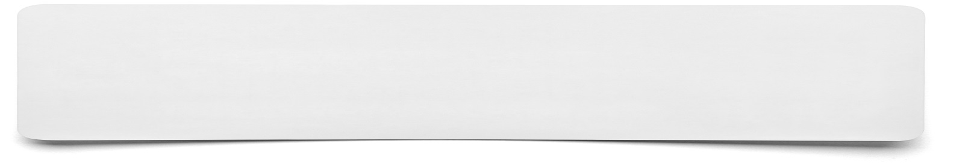**Traffic Lights**

Green: What is a strength and why?



Red: What definitely needs to be improved and why?

Amber: What could be extended or improved and why?